Student Check-In

This code is mainly to use the flask packages to complete the student check-in application. The main idea is that, firstly, we should write the html website including the QR code of the information inputting website. We can use this https://cli.im/url website to generate the QR code for the information inputting website. At this website, we need to get the student check-in information, which includes name, sex, studentID and date. After getting student information, we need to generate one excel form to log these information. The third website is to show the check-in successful message.

In this case, I used the local host address as the website address, because I don’t have the server to run my own website.

1. Figure out the way to use flask package

The flask package can help us to send the back-end method to front-end, which means that we can use this frame to do some things to the website.

1. Write the three html websites

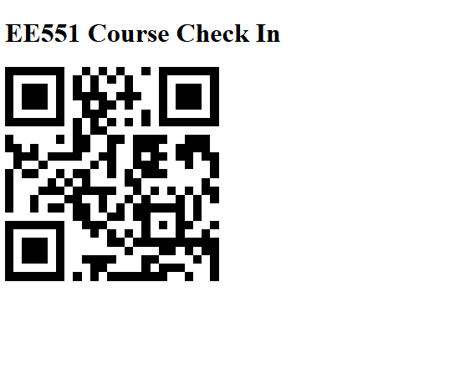

This is the first website, which is including course name and the QR code. The QR code should link to our own website to get the student information. As I said, because I don’t rent a server, this QR code now is invalid.

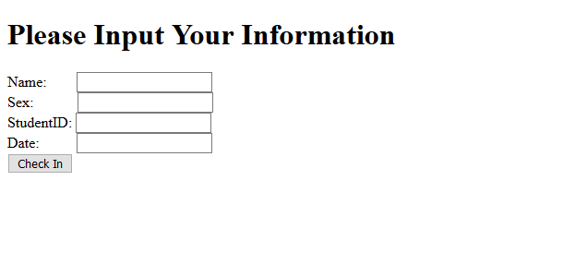

The second website is to record the student information, which is linked to the QR code.

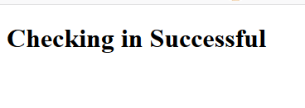

The third website tells the student that they finished check-in.

1. Saving the student check-in information and forming the excel table

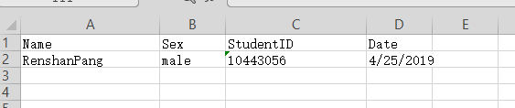

This form saves the student information.